**CH 412 LA: INORGANIC CHEMISTRY LABORATORY (Spring 2021)**

**Title:**

1. **Purpose: (1 point)**

**The purpose of this experiment is to illustrate the oxidative and reductive properties of H2O­2 and H2S, and to illustrate the formation of multi-sulfur compounds.**

1. **Drawing of structure of the main compound or balanced chemical equation if synthesis is performed: (1 point)**





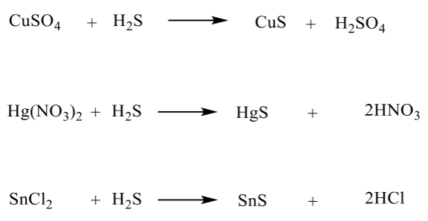

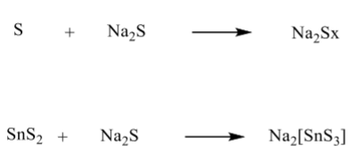

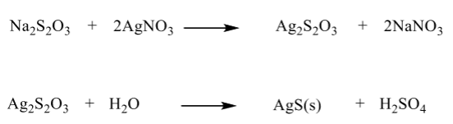

**3. Reagents and the major product (up to 5 points)**

|  |  |  |  |  |  |  |
| --- | --- | --- | --- | --- | --- | --- |
| **Name** | **M.W.**  (0.5 pts) | **Density**  (0.5 pts) | **Amount (grams/mL)**  (0.5 pts) | **Moles**  (0.5 pts) | **Hazards/Precautions**  **(MSDS data) and melting point or boiling point** (2 pts) | **Role of the reagent** (1 pts)* |
| Hydrogen peroxide | 34.015 | 1.11 g/cm3 | -- | -- | Strong oxidizer, harmful if swallowed. Causes severe skin burns and eye damage.  MP: -0.41°C  BP: 150.2°C | Reactant |
| Hydrogen sulfide | 34.08 | 1.363 g/dm3 | 1 mL 0.2 M | 0.0002 | Fatal if inhaled. May cause respiratory irritation.  MP: -82°C  BP: -60°C | Reactant |
| Lead (II) nitrate | 331.20 | 4.53 g/cm3 | -- | -- | Strong oxidizer. Harmful if swallowed or inhaled. May cause central nervous system effects.  MP: 470°C | Reactant |
| Potassium permanganate | 158.03 | 2.70 g/cm3 | Several drops 0.01M | -- | Strong oxidizer. Causes severe eye and skin irritation with possible burns.  MP: 240°C | Reactant |
| Sulfuric acid | 98.07 | 1.84 g/cm3 | -- | -- | Causes eye and skin burns. Causes digestive and respiratory tract burns. May be fatal if mist inhaled.  MP: 10°C  BP: 290-338°C | Reactant |
| Copper (II) sulfate | 249.68 | 2.2840 g/cm3 | 0.5 mL 0.2 M | 0.0001 | Causes irritation and possible burns by all routes of exposure.  MP: 110°C  BP: 150°C | Reactant |
| Mercury (II) nitrate | 324.60 | 4.3 g/cm3 | 0.5 mL 0.2 M | 0.0001 | Causes digestive and respiratory tract burns. Causes eye and skin burns.  MP: 77-79°C | Reactant |
| Tin (II) chloride | 189.60 | 3.950 g/cm3 | 0.5 mL 0.2 M | 0.0001 | Causes burns by all exposure routes. Harmful if swallowed.  MP: 246°C  BP: 652°C | Reactant |
| Copper (II) sulfide | 95.61 | 4.6 g/cm3 | -- | -- | May cause skin, eye, and respiratory tract irritation.  MP: 220°C | Reactant |
| Sulfur | 32.06 | 2.07 g/cm3 | -- | -- | Flammable solid. Causes skin, eye, and respiratory tract irritation.  MP: 113°C  BP: 445°C | Reactant |
| Tin (IV) sulfide | 182.83 | 4.5 g/cm3 | -- | -- | Causes skin and serious eye irritation.  MP: 600°C | Product/reactant |
| Sodium thiosulfate | 158.11 | 1.667 g/cm3 | -- | -- | May cause eye, skin, and respiratory tract irritation.  MP: 48.3°C  BP: 100°C | Reactant |
| Silver nitrate | 169.87 | 4.35 g/cm3 | -- | -- | Strong oxidizer. Causes burns by all exposure routes.  MP: 212°C  BP: 433°C | Reactant |

**\*** Mention role as either reactant, solvent, catalyst or product

**4. Calculations: (1 point) (ignore it)**

Show each calculation for moles of reagents and for theoretical and actual yield. Fill in the box with the limiting reagent and theoretical yield:

The limiting reagent is

The theoretical yield is

**5. Procedure (up to 2 points)**

|  |  |
| --- | --- |
| **Procedure** | **Observations and Lab Data** |
| A summary of the procedure done with bullet points) | Color changes, exothermic or endothermic reactions, gas generation, etc.; tare weights for flasks, etc. |
| Part 1:   * Mix equal volume 0.2 M Pb(NO3)2 and H2S solution. Remove supernatant and add 30% H2O2 solution. Record observations. * Add several drops of 0.01M KMnO4 into test tube, followed by small amount of 0.1M H2SO4. Add 6% H2O2 solution in the test tube and observe.   Part 2:   * Add 0.5 mL 0.2M CuSO4, Hg(NO3)2, and SnCl2 solutions into three different test tubes separately containing 1.0 mL 0.2 M H2S solution. * Centrifuge test tubes, collect precipitations, and observe the color difference of precipitations. * Add small amount of 6M HCl so CuS tube and see if precipitation will dissolve. * Centrifuge and remove the supernatant. * Add small amount of HNO3 into test tube and observe precipitation dissolution. * Add small amount of sulfur powder into a test tube, followed by a small amount of 0.5 M Na2S. Heat the sample in 60°C water bath and observe solution color change. * Add this solution into SnS2 precipitation test tube and observe the precipitation dissolution. * Add 2.0 M HCl into above transparent solution and observe results.   Part 3:   * Add several drops of 0.5M Na2S2O3 solution into a test tube containing 0.5 mL 0.1 AgNO3. Keep adding until total 5.0 mL Na2S2O3 is added. Observe reactions. * In another experiment, place 5.0 mL 0.5 M Na2S2O3 solution in a test tube. Add 0.5 mL 0.1 M AgNO3 solution and observe reaction. * Observe and explain difference between the two reactions. |  |

**6.** Results; include actual yield in grams and % yield.

**Results (need to get signed by instructor or TA):**